

Digital image processing term paper

ECE5690 Winter2020



February 3, 2020

Name: LI lIN

WSU ID: ha5649

# 1. Histogram Function

Compute and display the histogram of an image, show parameters such as mean, standard

Deviation.

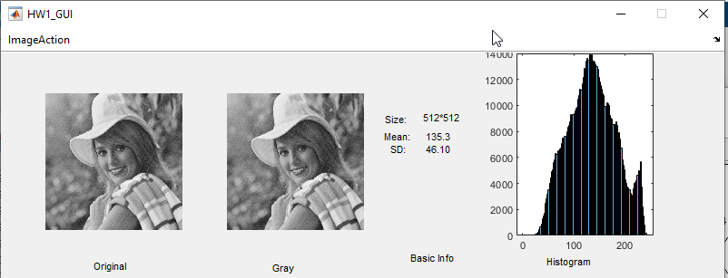

# 2. Reduce Gray Level

Reducing the number of gray levels (in integer powers of 2, from 256 to 2)

 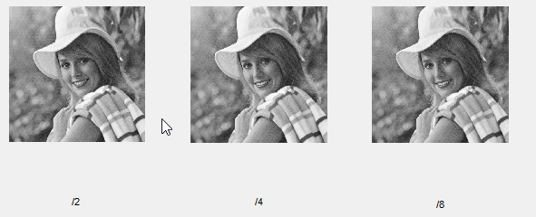

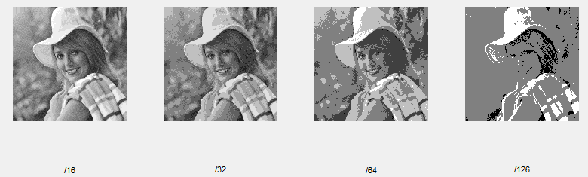

# 3. Zooming and Shrinking

Zooming and shrinking an image using nearest neighbor interpolation, Bilinear Interpolation